**FPS Counter**

The FPS Counter Script can be placed on a “Text” UI component in the canvas. The display text variable is to be assigned to the “Text” UI.

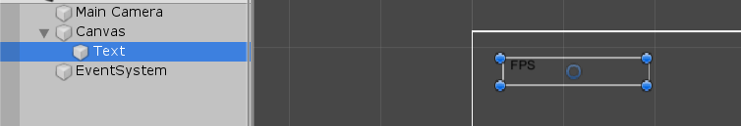

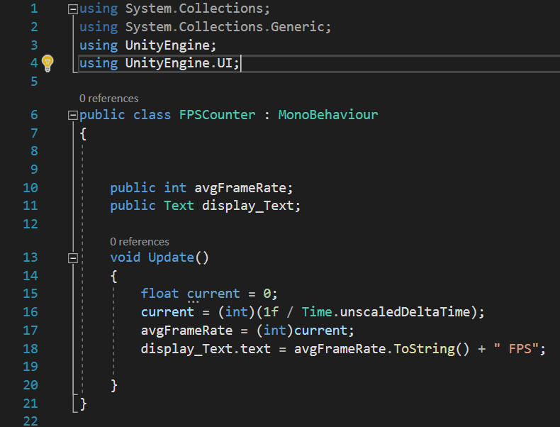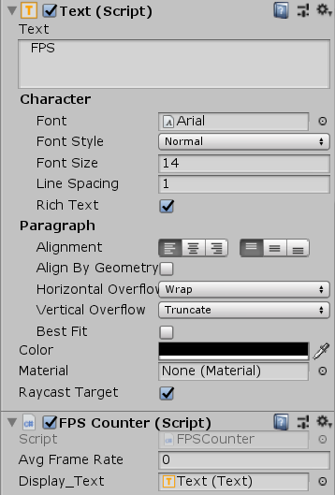

The script creates a float variable that is equal to 1 divided by the time between each frame. This returns a whole number that is equal to the frames drawn per second.

The script then sets that number to the text component in the canvas every frame.